SSN COLLEGE OF ENGINEERING, KALAVAKKAM
DEPARTMENT OF COMPUTER SCIENCE & ENGINEERING
Internet Programming Lab – CS6512
Programming Assignment 11 – DatabaseJSP using Apache Tomcat Server ________________________________________________________________________

Write index.jsp to display form with a submit button. Set the method attribute of the form to “get” to generate GET request to the server. Write a data.jsp which displays the records from the table when the button is clicked.

Follow the directory structure for creating DatabaseJSP Web application and follow the guidelines below to configure and deploy web application.

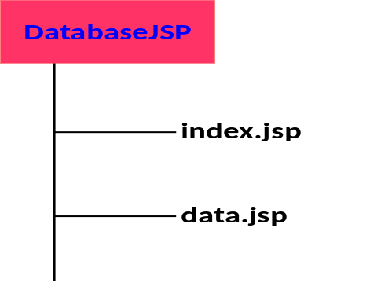

Create a FolderDatabaseJSP and keep index.jsp and data.jsp in that. Place the folder in webapps
Navigate to webapps→examples→WEB-INF→lib to get the files jstl.jar and standard.jar file
Create a folder tree WEB-INF→lib and place the files in HelloJSP

